Title 15—elected officials
Division 30—Secretary of State
Chapter 9—Uniform Counting Standards
15 CSR 30-9.010 Uniform Counting Standards—Punch Card Voting Systems
(Rescinded June 30, 2024)
AUTHORITY: section 115.225, RSMo 2000. Original rule filed Aug. 8, 2001, effective March 1, 2002. Rescinded: Filed Nov. 29, 2023, effective June 30, 2024.

15 CSR 30-9.020 Uniform Counting Standards—Optical Scan Voting Systems
PURPOSE: This rule provides for standards to be used by election authorities when counting ballots cast using optical scan voting systems.
(1) The election authority shall be responsible for insuring that the standards provided for in this rule are followed when counting ballots cast using optical scan voting systems.
(2) Prior to tabulating ballots all machines shall be programmed to reject blank ballots where no votes are recorded, or where an overvote is registered in any race.
(A) In jurisdictions using precinct-based tabulators, the voter who cast the ballot shall review the ballot if rejected, to determine if he/she wishes to make any changes to the ballot or if he/she would like to spoil their ballot and receive another ballot.
(B) In jurisdictions using centrally based tabulators, if a ballot is so rejected, it shall be reviewed by a bipartisan team using the following criteria:
1. If a ballot is determined to be damaged, the bipartisan team shall spoil the original ballot and duplicate the voter’s intent on the new ballot, provided that there is an undisputed method of matching the duplicate ballot with its original after it has been placed with the remainder of the ballots from that precinct; and
2. The provisions of sections (3), (4), (5), and (6) of this rule.
(3) The following marks shall be considered expressions of voter intent:
(A) Any ballot which is properly marked in the target area, as specified by the ballot instructions.
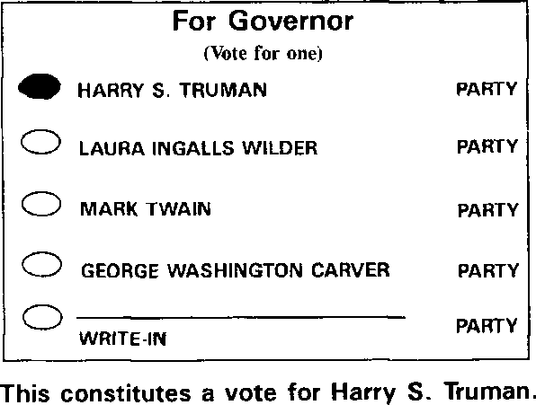

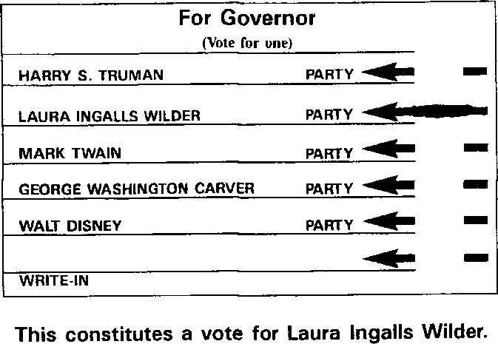

(B) Any ballot that is properly marked with any device other than the approved marking device which prevents a machine count shall be counted as a vote.
(C) The target area next to a candidate or issue preference is circled.

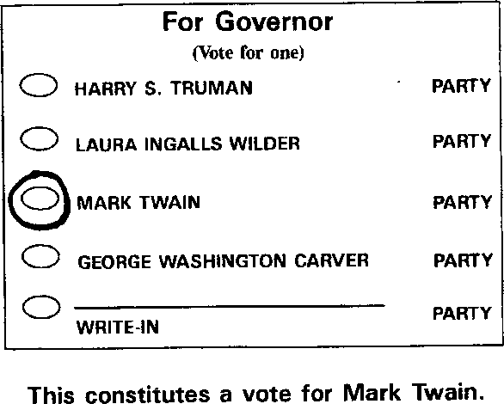
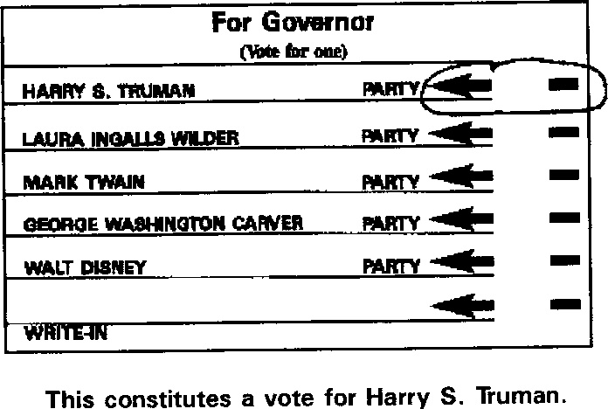

(D) There is a distinguishing mark in the target area next to a candidate or issue preference including but not limited to the following examples:
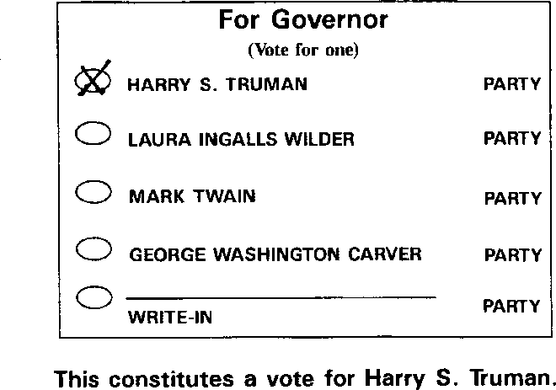

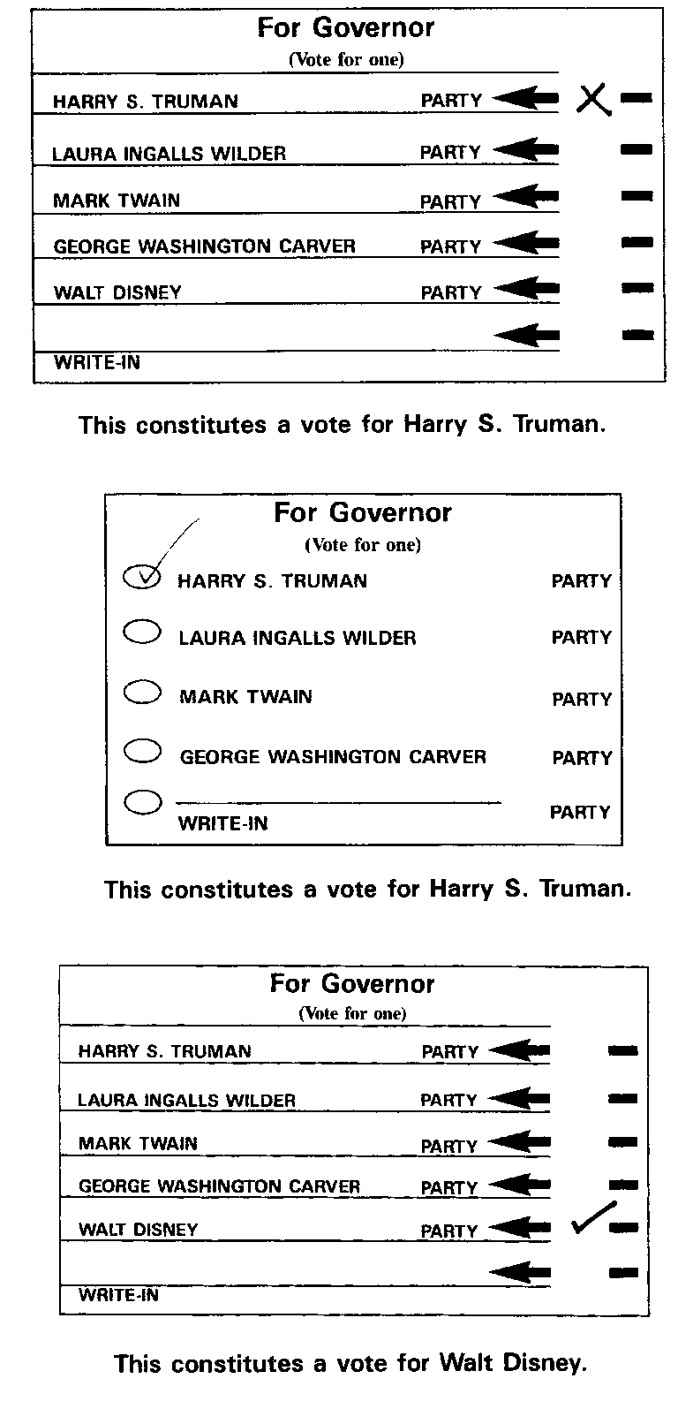

(E) The name of a candidate or issue preference is circled.
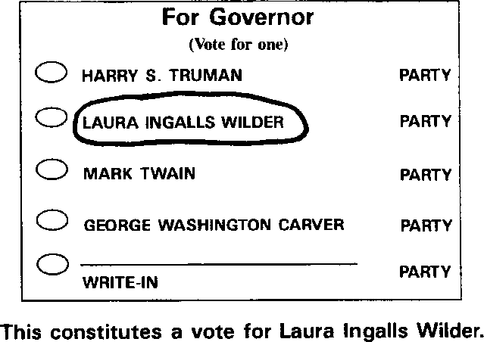

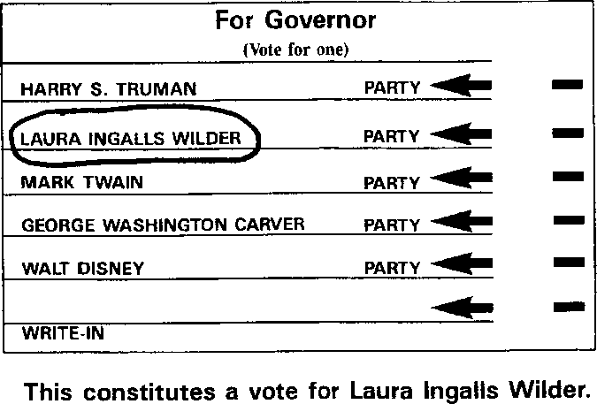

(F) In the event that there are distinguishing marks for two (2) or more candidates, clarified by an additional mark or marks that appear to indicate support, the ballot shall be counted as a vote for the candidate with the additional, clarifying marks.
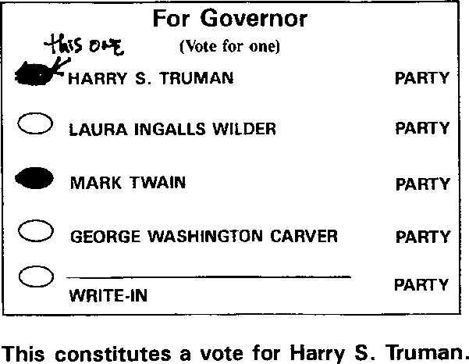

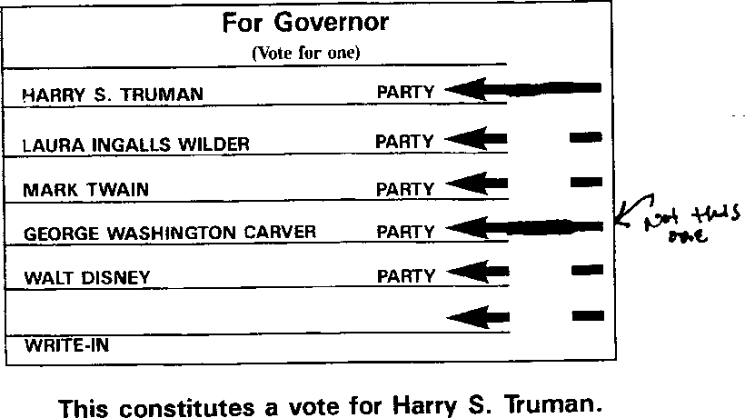

(4) If a voter marks more candidates than there are positions to be elected for that office, without any additional clarifying marks, the marks do not constitute a valid vote for any candidate in that race and the ballot shall be deemed an overvote.
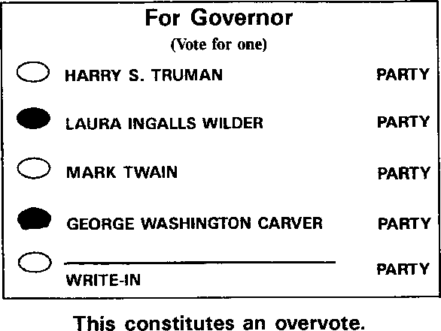
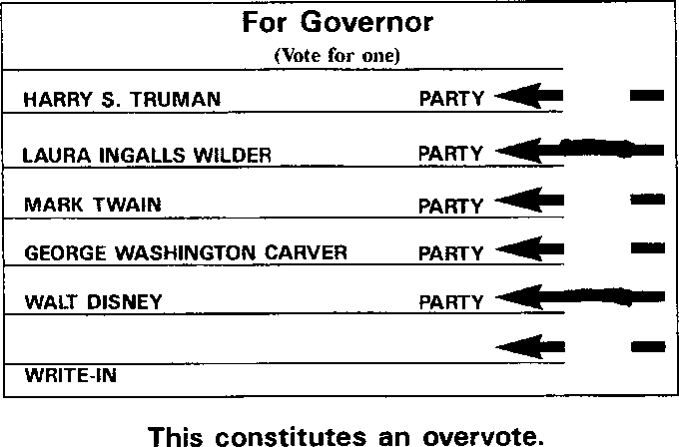

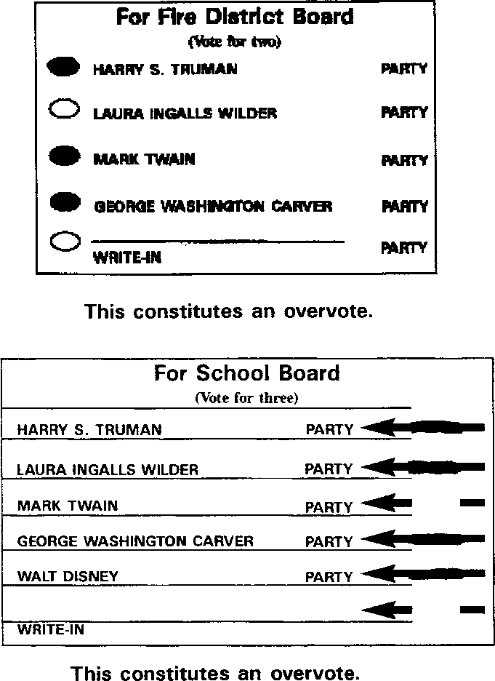

(5) In jurisdictions using optical scan systems, a valid vote for a write-in candidate must include the following:
(A) A distinguishing mark in the target area next to the name of the candidate;
(B) The name of a qualified write-in candidate. If the name of the candidate, as written by the voter, is substantially as declared by the candidate it shall be counted, or in those circumstances where the names of candidates are similar, the names of candidates as shown on voter registration records shall be counted; and
(C) The name of the office for which the candidate is to be elected.

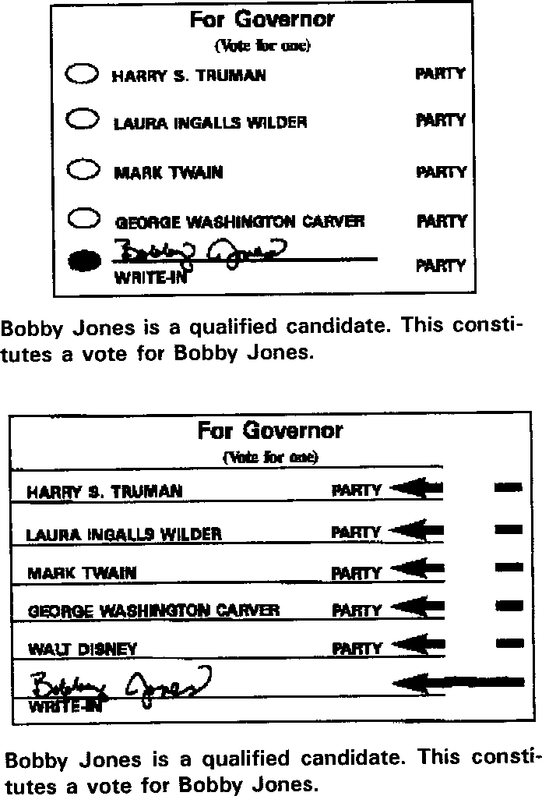

(6) If a voter designates a vote for a named candidate on the ballot and also provides for a write-in candidate in the same race it shall be treated as follows:
(A) If a voter designates a vote for a named candidate on the ballot and writes in the same candidate in the write-in area, the vote shall count for that candidate.

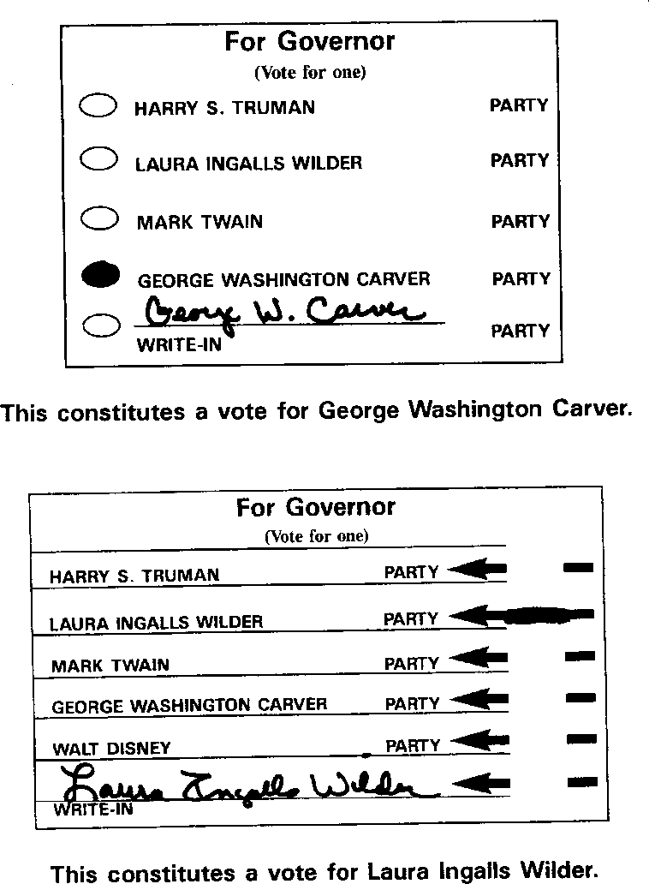
(B) If a voter designates a vote for a named candidate on the ballot and writes in the name of a qualified write-in candidate or the name of a different named candidate on the ballot in that race and makes a distinguishing mark in the target area next to the name of the write-in candidate, it shall be considered an overvote with neither candidate receiving credit for the vote.

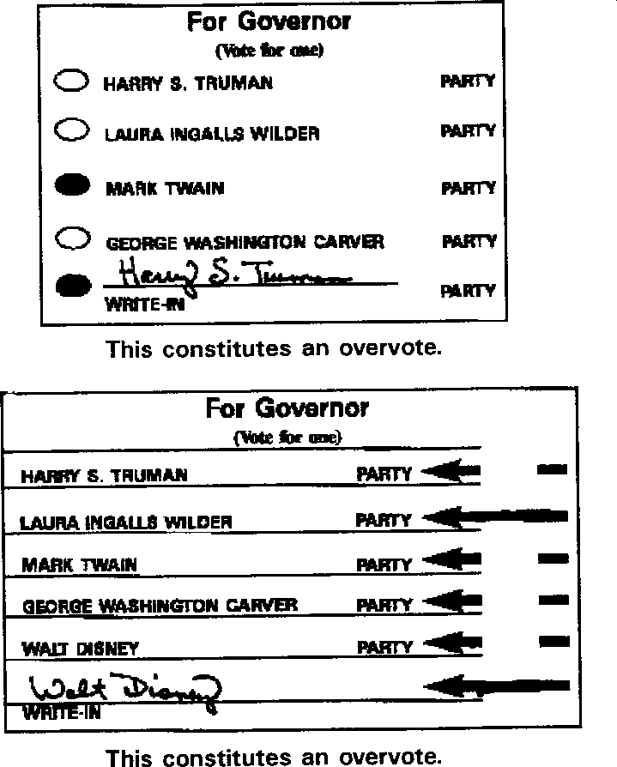

(C) If a voter designates a vote for a named candidate on the ballot and writes in the name of a person who is not a qualified write-in candidate and not a named candidate on the ballot in that race, it shall be considered a vote for the named candidate.
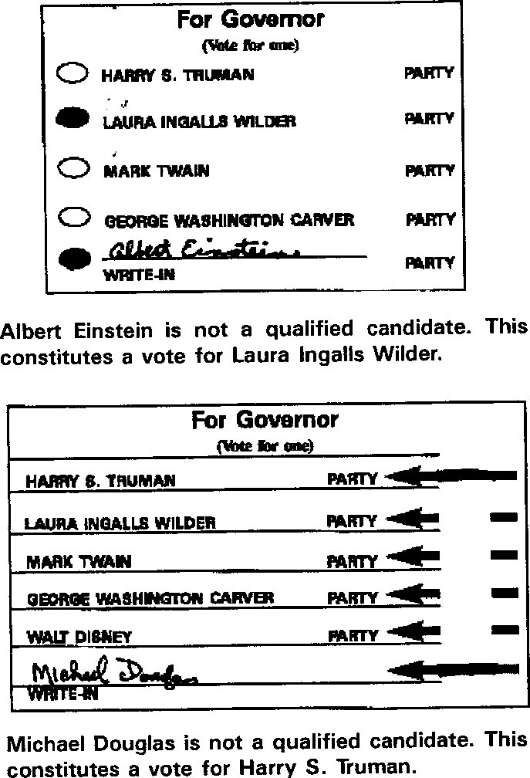

(7) Whenever a hand recount of votes of optical scan ballots is ordered, the provisions of this rule shall be used to determine voter intent.
AUTHORITY: section 115.225, RSMo Supp. 2023.* Original rule filed Aug. 8, 2001, effective March 1, 2002. Emergency rescission filed Feb. 2, 2006, effective Feb. 18, 2006, expired Aug. 16, 2006. Emergency rule filed Feb. 2, 2006, effective Feb. 18, 2006, terminated April 30, 2006. Emergency rule filed April 20, 2006, effective April 30, 2006, expired Aug. 16, 2006. Rescinded and readopted: Filed Feb. 2, 2006, effective July 30, 2006. Amended: Filed Nov. 29, 2023, effective June 30, 2024.
*Original authority: 115.225, RSMo 1977, amended 1993, 1995, 2002, 2006, 2018, 2022.

15 CSR 30-9.030 Uniform Counting Standards—Paper Ballots
PURPOSE: This rule provides for standards to be used by election authorities when counting ballots cast using paper ballots.
(1) The election authority shall be responsible for insuring that the standards provided for in this rule are followed when counting ballots cast using paper ballots.
(2) The following marks shall be considered expressions of voter intent:
(A) Any ballot which is properly marked, as specified by the ballot instructions, in the target area.
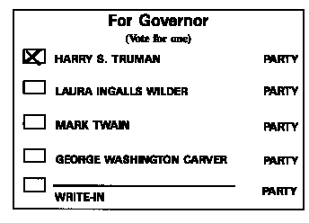
This constitutes a vote for Harry S. Truman.

(B) The target area next to a candidate or issue preference is circled.
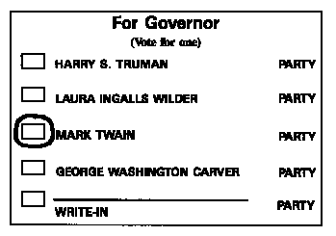
This constitutes a vote for Mark Twain.
(C) There is a distinguishing mark in the target area next to a candidate or issue preference including but not limited to the following examples:
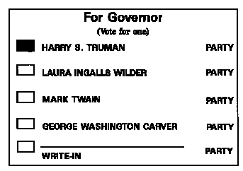
This constitutes a vote for Harry S. Truman.

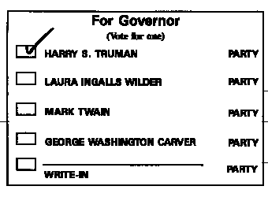
This constitutes a vote for Harry S. Truman.

(D) The name of a candidate or issue preference is circled.
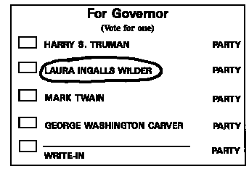

This constitutes a vote for Laura Ingalls Wilder.

(E) In the event that there are distinguishing marks for two (2) or more candidates, clarified by an additional mark or marks that appear to indicate support, the ballot shall be counted as a vote for the candidate with the additional, clarifying marks.

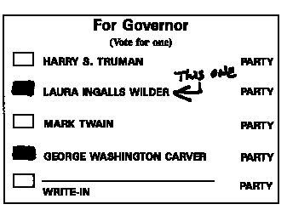
This constitutes a vote for Laura Ingalls Wilder.

(3) If a voter marks more candidates than there are positions to be elected for that office, without any additional clarifying marks, the marks do not constitute a valid vote for any candidate in that race and the ballot shall be deemed an overvote.
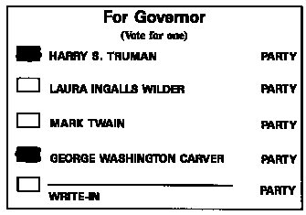
This constitutes an overvote.
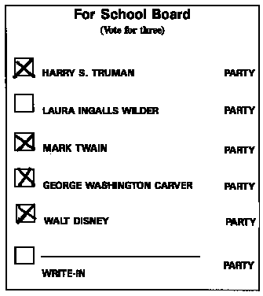
This constitutes an overvote.
(4) In jurisdictions using paper ballots, a valid vote for a write-in candidate must include the following:
(A) A distinguishing mark in the target area next to the name of the candidate;
(B) The name of a qualified write-in candidate. If the name of the candidate, as written by the voter, is substantially as declared by the candidate it shall be counted, or in those circumstances where the names of candidates are similar, the names of candidates as shown on voter registration records shall be counted.
(C) The name of the office for which the candidate is to be elected.
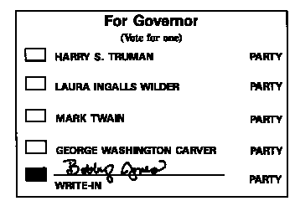
Bobby Jones is a qualified candidate. This constitutes a vote for Bobby Jones.

(5) If a voter designates a vote for a named candidate on the ballot and also provides for a write-in candidate in the same race it shall be treated as follows:
(A) If a voter designates a vote for a named candidate on the ballot and writes in the same candidate in the write-in area, the vote shall count for that candidate.

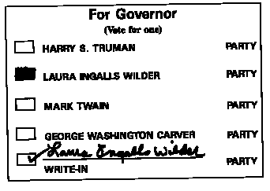
This constitutes a vote for Laura Ingalls Wilder.

(B) If a voter designates a vote for a named candidate on the ballot and writes in the name of a qualified write-in candidate or the name of a different named candidate on the ballot in that race and makes a distinguishing mark in the target area next to the name of the write-in candidate, it shall be considered an overvote with neither candidate receiving credit for the vote.

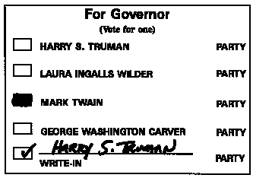
This constitutes an overvote.

(C) If a voter designates a vote for a named candidate on the ballot and writes in the name of a person who is not a qualified write-in candidate and not a named candidate on the ballot in that race, it shall be considered a vote for the named candidate.
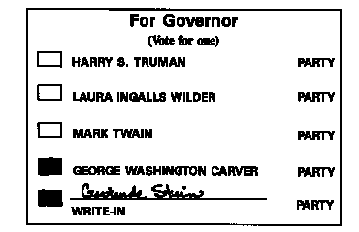
Gertrude Stein is not a qualified candidate. This shall constitute a vote for George Washington Carver.
(6) Whenever a hand recount of votes of paper ballots is ordered, the provisions of this rule shall be used to determine voter intent.
AUTHORITY: section 115.225, RSMo Supp. 2005.* Original rule filed Aug. 8, 2001, effective March 1, 2002. Emergency rescission filed Feb. 2, 2006, effective Feb. 18, 2006, expired Aug. 16, 2006. Emergency rule filed Feb. 2, 2006, effective Feb. 18, 2006, terminated April 30, 2006. Emergency rule filed April 20, 2006, effective April 30, 2006, expired Aug. 16, 2006. Rescinded and readopted: Filed Feb. 2, 2006, effective July 30, 2006.

*Original authority: 115.225, RSMo 1977, amended 1993, 1995, 2002.

15 CSR 30-9.040 Write-In Stickers
PURPOSE: This rule sets out the procedures for the process of using stickers to vote for write-in candidates.
(1) The sticker shall contain the name of a candidate, office sought, and a distinguishing mark in the square immediately preceding the name of the candidate and shall be approximately one inch by three inches (1" × 3") in size with black print on a white background.
(2) The sticker shall be placed by the voter on the write-in line designating the office sought or the sticker shall be placed by the voter on the write-in line on the secrecy envelope.
AUTHORITY: section 115.439.5, RSMo Supp. 2002.* Emergency rule filed Oct. 11, 2002, effective Oct. 21, 2002, expired April 18, 2003. Original rule filed Oct. 18, 2002, effective April 30, 2003.
*Original authority: 115.439, RSMo 1977, amended 1993, 2002.

