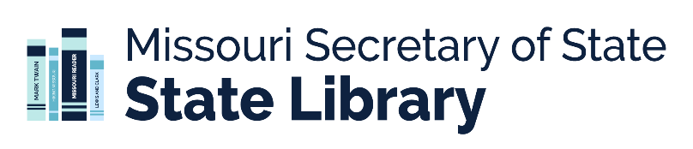
Timeline for Summer Library Programming 2027
This is a general timeline for public libraries that offer summer library programs. It is not meant to be a comprehensive list of activities; rather it is intended as a guide for library staff who are new to summer programming and/or unfamiliar with how the Missouri State Library supports summer programming. Note: it does not include information about the Summer Library Program grant funded by LSTA.

October
- CSLP manual
  - The Collaborative Summer Library Program (CSLP) manual is released! The Missouri State Library pays for digital access to this programming manual for each state aid eligible public library.
  - The programming manual access code is sent to library directors via the PubLibDir listserv.
  - An announcement that the manual is ready (and that the code has been emailed to directors) is sent out over the MOYAC listserv.
- CSLP shop
  - The Collaborative Summer Library Program (CSLP) shop opens for libraries that want to purchase CSLP themed merch for their summer program.
  - Each year, state aid eligible libraries are allotted a set amount of general revenue funds to make purchases in the CSLP shop. The amount varies by year. This is a reimbursement fund, meaning that libraries must make their purchases from the CSLP shop and then request reimbursement from the State Library.
  - Directors will be notified of their apportionment in October and asked to return a signed agreement in November. Funds must be used by the end of January and the paid invoice and request for reimbursement must be sent to the State Library by the end of May.

October – November
- SLP workshops
  - The State Library offers a series of workshops (in person and/or virtual) to help libraries prepare for their summer programs.
  - These workshops are available at no cost to libraries.
  - Notification of the workshops and a link to register are sent out via the MOYAC listserv and the Show Me Express newsletter.
- CSLP shop
  - Directors should return their signed CSLP shop agreement to the State Library and libraries can look through the CSLP shop to *plan* their purchases (don’t make purchases until you get the signed agreement back from the State Library).
- General plans – this is also a good time for directors and summer program staff to determine outcomes, set goals, and develop evaluation tools. You could also discuss programming ideas, potential presenters, and outreach activities.

December
- CSLP Summer Symposium – the Collaborative Summer Library Program (CSLP) offers a free, virtual symposium to support libraries as they plan their summer program. Information about the symposium will be sent out via the MOYAC listserv.
- CSLP Shop – once library directors receive the signed CSLP shop agreement back from the State Library, purchases can be made from the CSLP shop.
- General plans – continue discussions about programming, potential presenters, and outreach activities.

January
- CSLP Shop – finalize purchases from the CSLP shop. Once libraries have a paid invoice from CSLP, they should send that invoice, along with their request for reimbursement, to the State Library.

January – March
- Plan your promotional strategies.
- Start planning outreach programs with community partners.
- Start planning outreach to schools.
- Contact and schedule presenters (note: if you have applied for an LSTA Summer Library Program grant, do not hire presenters until the grant has been awarded).

April – May
- If you made purchases from the CSLP shop and are eligible for reimbursement, make sure you have requested that reimbursement by the end of May.
- Contact local businesses and organizations for sponsorship support.
- Continue planning outreach programs with community partners.
- Visit schools.
- PROMOTE!!! See the CSLP manual for resources and ideas.

Summer
- Good luck with your summer programs! Have fun and remember to keep statistics and evaluate your programs.

August – September
- Celebrate and have wrap-up meeting with programming staff.
- Report your successes. You will receive links to a Missouri State Library summer program report (required) and a CSLP summer library survey (highly encouraged).
- Take a breath and get ready to start planning for next summer!

Questions?
Contact Katie Dunne, Youth Services Consultant with the Missouri State Library,
at katie.dunne@sos.mo.gov or 573-522-9564.

