Wolfner Advisory Council Meeting
James C. Kirkpatrick State Information Center
SOS State Library Conference room, 2nd Fl.
February 19, 2021

Welcome/ Call to Order
Roll Call

Peter Altschul
Leslie Bowman
Lori Brown
Steven Daley
Mandy Dovin
Melissa Kane
Joanne Lewis
Paul Mimms
Rita McGuire
Kerry Smith
Trish Vincent
Robin Westphal
Verhonda Winters
Randy Wright

Absent

Kathleen Gallagher
Katy Cawdron
Walt Ross

Call to order Peter Altschul at – 10:00 am

Approval of Minutes for August
- Moved by - Mandy
- Seconded by - Rita
- Approved – Peter

Executive Deputy Secretary of State, Trish Vincent
Wolfner Library received kudos for great work achieved during the pandemic as well as several staff changes. Trish welcomes Randy Wright to Wolfner Library as the new recording studio manager. The Secretary of State is working on the upcoming year’s budget to fight for every dollar available for our libraries and Wolfner; this is a priority for the Secretary. We have increased participation through webinar meetings. Secretary of State Staff have continued working through the COVID-19 pandemic while still providing excellent customer service to our patrons. Trish appreciates the service and support of the council to the Wolfner Library as well as the continued work of all library staff.

Advisory Council Comments and Recommendations: None

Director’s Report, Leslie Bowman

- 460K Circulation number for the year
- 35,385 Patron Conversations, up from 21,524 in 2019
- 2,448 hours donated by Volunteers
- 77 Books Produced by the Wolfner Recording Studio
- 1,010 New patrons
- 5 Virtual story times
- 7 Virtual crafts
- 6 Podcasts
- 6 Author or Speaker Events
- 1 New Wolfie created by Jacob Schloss, graphic designer extraordinaire!

Wolfner response during the COVID-19 Pandemic

- Continuing to quarantine incoming mail for 72 hours.
- 3 Network Libraries of the National Library Service (NLS) are still closed. 27 are partially open, 69 are fully open.

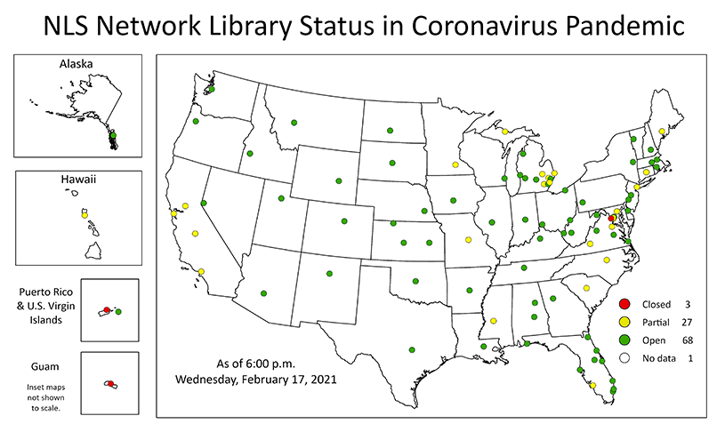
- In the Winter 2021 Wolfner News, Wolfner sent out the biennial patron survey. We have received 104 responses thus far.
- Wolfner is collecting emails, cards, and letters of appreciation for our Wolfner Volunteers. We will be honoring our volunteers in April with a gift from the Friends of Wolfner Library and the many thanks from our patrons.
- The Duplication on Demand (DoD) conversion is in process. Equipment arrived December 1, 2020. SOS IT installed the two stations. Wolfner ordered a second printer and second set of bar code readers. Staff will be practicing with the equipment and software before we launch the first 50 patrons.
- Wolfner was chosen as one of eight states to pilot the new voice activated player. We will be provided 18-20 Samsung 20S or X to work with 18 patrons. The players will have their own BARD account. The patrons chosen must have internet as these are web-based applications. Our next information meeting with NLS is Thursday, Feb. 25, 2021.
- The Refreshable Braille Display pilot is taking place in two states. Wolfner will get two devices to test after the pilot is complete.
- The Friends of Wolfner Library have funded a new tzotchke…a touch less tool for the keychain.
Staff at Wolfner
- Randy Wright has joined us at Production and Special Projects Manager.
- Verhonda Winters our Circulations Manager.
- Lori Brown our Readers Services Manager.
- Adrianne Thompson has joined us as Tech 1.
- Michelle Bain has joined us as Circulation Processing Assistant.
- Kenna Tervo was promoted to Reader Advisor from CPA.
Youth Services
- Wolfie’s Den updates with New Year Storytime, Valentine Storytime, Stick Star Ornaments, Tactile Snowflakes, and Valentine Friendship Bracelet.
- New podcasts are Dark was the Night: Blind Willie Johnson’s Journey to the Stars, Learning about Guide Dogs, Learning about NFB, and upcoming Advocacy podcast.
Adult Services
- Salena Morgan launched a new Evening with Wolfner book club.
- Adult Winter Reading Program has 87 participants. This is up from 43 last year.
- The Laura Keyes event had 52 participants. Wolfner would like to have more of these events in the future. The Friends of the Library have agreed to fund our endeavor.
Questions:
Peter – What are the options for outreach in the rural areas?
Leslie – Since COVID Wolfner has been under a travel banned.
- Lori has been working with the institutions and public libraries to make sure they have a demo site to show the machine and a BARD account to help with the downloading process and that they know about our services and who all we can help.
- Wolfner is encouraging all library directors to call our office if they have anyone that has a print disability so we can see if our services are available to the patron.
- Emails from different people across the state advising of events being help so we send information about our services and who qualifies.
- Wolfner is looking forward to being able to go out and serve the public in person and reaching those hard to reach patrons in the rural areas of the state.

Advisory Council Recommendations - None

State Library, Robin Westphal
The Secretary has given lots of praise to the Wolfner Library and Public Libraries relating to how they have continued serving the patrons of the library during COVID. Robins motto is not too use any COVID buzz words and most reflect on the new way we handle and serve our patrons while being flexible. The calendar year end review for 2020 the State Library gave monetary and support assistance to libraries as follows:

Library Development:

- Support the (152) Public Library Districts (350) library unit buildings in the State of Missouri.
- There were (252) grants awarded to public libraries.
- Over ($3k) in federal dollars plus and additional allocation specific for COVID relief.
- Increased the number of continuing education opportunities for librarians. Wolfner library staff hosted and attended the events.
- There was (225) live webinar training events with over 56K views. Some participants viewed the trainings live and library staff archived all the training events for future viewing.
- Crisis management; new director boot camp and wide variety of other advocacy programs.
- Monday February 22, 2021 is Library Advocacy Day, where public libraries, directors and boards will be convening on getting information on how to speak to legislatures on the importance of library service. This will be a virtual meeting sponsored by Missouri Library Association (Annually). The association will help libraries schedule the virtual meetings with their perspective legislature.

Reference Services:

- Serves the 60K plus employees from all Departments governed by the State of MO.
- Create and provide resources for public library staff and the state
- Professional development collection specific for library personnel and managing libraries.
- Frequently served patrons are the State of MO employees.
- Houses governors executive orders on the website:
  - Executive Orders
  - Emergency Proclamation
    - Viewed over 500K times
  - COVID reopening guide document created in house as a resource for libraries when ready to physically serve the public
    - Viewed about 800 times a month in 2020
- Issued library cards to state employees and hosted a campaign in 2020 to encourage more state employees to sign-up for library service.
- Library card distribution went up by 147% increase to help promote the service available.
- Since most state employees have been working from home reference services had to adapt and modify deliveries for the state employees to receive materials from the library.
- Interlibrary loan request had to be shipped to individual state employees homes and the service rate was 99% overall.
- Very proud of what the state library staff have done amongst the changes that have taken place in 2020.

Advisory Council Recommendations
- Steve - Recommends the Internet Research Boot Camp
- Peter - Thoughts on future changes of library service after COVID
- Robin – Perfecting delivery, curbside and remote services will continue since many state employees will continue to work from home in the future.
  - COVID created and atmosphere for libraries to change and enhance their service model by the need for more electronic service, e-books and notary service. Patrons will expect the same service in the future and will continue to need them more in the future. There is no going back to service model before COVID.
- Mandy – Kudos for adapting in a crisis to serve state employees.

Public Services Report, Lori Brown

- The Reader Services staff have made 4,360 patron contacts between December 11, and February 1, and have added 158 new patrons.
- Wolfner currently serves 6,478 active patrons.
- Of those, 480 are youth patrons.
- Wolfner now serves 634 Institutions.
- From our circulation team, Kenna Tervo volunteered to fill in at the main desk as our Tech 1 while we were searching for a replacement.
- We welcomed Adrianne Thomason as our Tech 1 to our team in January. Adrianne has been a fast learner, enjoys speaking to our patrons, and is enthusiastic about doing more to serve our patrons.
- We were delighted with Kenna’s customer service skills filling in as our Tech 1, and she thoroughly enjoyed speaking with our patrons. We decided to offer her the open Reader Advisor position, and she jumped at the offer. As a Reader Advisor, she has excelled and is eager to help our patrons.
- The Reader Advisors have been busy preparing for Digital on Demand.
- We have made sure that our patron records are up-to-date, and they are placed a Nightly Shipment Cutoff that will serve their needs when they transition to Digital on Demand.
- We have contacted each calendar request patron to adjust their record for a smooth transition to Digital on Demand.
- We have created and added patrons to a list to transition to Digital on Demand.

Questions:

Peter – Briefly explain DoD.
Lori – DoD is a way to serve our patrons better.
- We have been working with physical copies ever since the Wolfner Library opened.
- The patrons would have to wait for a physical copy of a book to be available before we could mail it to them.
- DoD lets patrons download any book even if there is not a physical copy.
- The computer will assign books on patrons request list doing the overnight process.
- The circulation team will copy the books onto a cartridge made specifically for that patron it will ship out the next day.
- The benefits of DoD:
  - You never have to wait for a book to be physically available.
  - Instead of one book one cartridge (which is our mainstay) we will be loading 8 books on a cartridge.
  - Each patrons will have approximately 4 cartridges available to them.
  - Heavy reader patrons will not have a stack of 20 books instead they will have 4 cartridges that will store at least 40 books or more depending on that patron’s speed of reading.
Mandy – How does DoD impact the patron with the basic machine?
Lori – An update to the software of the basic machine will happen automatically when the cartridge is connected to the machine.
- This will allow the patron to hold down the play/stop button for a few seconds the machine will automatically speak (bookshelf mode).
- Once in bookshelf mode the patron will arrow forward through the titles or they can skip titles by using the arrow forward or backwards.
- Once patron has chosen the book to read they can hit the play/stop button which will play the book. Update will be on all cartridges
- There is no longer a need for the advanced machine.
- Wolfner is slowly adding 50 patrons at a time to the new DoD process.
- The Wolfner managers and circulation team will ensure the new equipment and system is properly working before mailing out any cartridges to the patrons.
Kerry – Update is for all players (basic, advanced).
- The advance machine already has an easy way to get to bookshelf mode.
- If a patrons does not know how to use bookshelf mode they can follow the above instructions for the basic machine with the updated software.
Leslie – If a patron has the standard machine Wolfner can provide
a remote control that works (30 feet away).
- This remote controls as the same functions as an advance machine which has been available for some time.
Paul – Is there any literature available that can be handed out to
Patrons?
Leslie -There is information in the current newsletter which has and
Information page that explains the DoD process.
- Wolfner will not transition patrons to the new process to until they verify the cartridges works as intended.
- Reader Advisors will contact those 50 pilot patrons to explain the process before sending the new DoD cartridge.
Lori – Will send instructions to Paul for the new DoD process

- From December 11- February 11, we have added 158 individuals as new patrons.

Peter – Please compare last year’s numbers to this year’s numbers?
Lori – Explained we are right on target.
Peter – Was curious if COVID was a factor for the increase.

Advisory Council Recommendations - None

Circulation Report, Verhonda Winters
Items circulated
  - Books and misc. items 69,744
  - Equipment Items 502

Duplication production
  - 5,181 titles
  - 6,626 copies
  - 632 Winter 2021 Wolfner News on cartridge

Advisory Council Recommendations - None

Recording Studio, Randy Wright

- Wolfner has the volunteers back on a limited schedule. The recording studio is able to have two sessions a day with major cleaning in between. The reviewing cubicles are also available for two sessions a day. In order to keep our volunteers and staff save, we have implemented the following: major scrubbing of all surfaces including microphones; covering keyboards and mice with saran wrap; quarantining books for 72 hours; and, wearing masks unless in the cubicle or the booth.

- During the time period from the last Wolfpack Advisory Council meeting through yesterday, February 18, 2021…
  - 26 volunteers, during a timeframe of 49 working days, donated 451 hours to Wolfner’s recording services onsite and 118 hours reviewing at home on two laptops. These 569 total volunteer hours result in an average of 11.6 hours donated per working day. The volunteer with most time recorded donated 51 hours of his time to Wolfner (9% of all volunteer hours).
  - The recording studio is still able to have two sessions a day with major cleaning in between. The reviewing cubicles are also available for two sessions a day.
  - Keeping our volunteers and staff safe and healthy is still a top priority. This includes:
    - Major scrubbing of all surfaces such as microphones, chairs, door handles, and book stands in both the studio and the cubicles
    - Covering every computer keyboard and mouse with saran wrap before every recording session
    - Quarantining books for 72 hours
    - Wearing masks when not in a cubicle or the booth.
  - 19 books have been recorded and produced on BARD, bringing Wolfner’s total to 888 approved audio books. These new entries include:
    - 2 rated for preschool – grade 2
    - 1 rated for grades 3 – 6
    - 4 rated for grades 4 – 7
    - 2 rated for grades 6 – 9
    - 3 rated for junior and senior high
    - 3 rated for senior high and adults
    - 4 rated for adults
  - 31 intention notices have been filed for upcoming recording projects.
  - An evaluation of need is currently being conducted concerning the addition of two to three laptops for volunteers to use for reviewing newly recorded books at home.
  - Wolfner continues to prepare for the state’s bicentennial year by acquiring Missouri-themed books for recording.
  - Leslie Bowman, Randy Wright, and Brandon Lammers completed online training for NS01 standards on February 9th, conducted by Philip Carbo and Paula Bhamani with NLS. NS02 training will follow at a later date.
  - Of the 49 final nominees for the 2020-2021 MASL Readers Awards, Wolfner has produced and uploaded 13 to BARD. These include
    - 5 Show Me (Grades 1-3)
    - 4 Truman (Grades 6-8)
    - 4 Gateway (Grades 9-12)
  - After asking patrons in our Winter 2021 newsletter for notes of appreciation to share at the upcoming virtual volunteer celebration in April, we have received notes from across the state, including the following:
    - Dear Folks of the Recording Dept.: I am so grateful there are people like you to take time to make my days. It is wonderful to listen to the books I receive from the library. I am 83 years of age with M.D. I cannot see small print. God bless you all! (Lorraine Strain, Gilman City, MO)
    - I salute all the volunteers that read the books for me. I have Alzheimer’s, so I need to repeat many times to comprehend what is being read. If I were reading, I would probably just put the book down because I would get frustrated. I salute you and God bless your hard work!!! (Gary Twyman, Independence, MO)
  - In lieu of the annual volunteer appreciation banquet, we will be giving each of our volunteers a canvas tote bag and a self-opening umbrella to express our gratitude. Both gifts are sponsored by the Friends of the Wolfner Library and imprinted with the Wolfner Library logo and contact information.
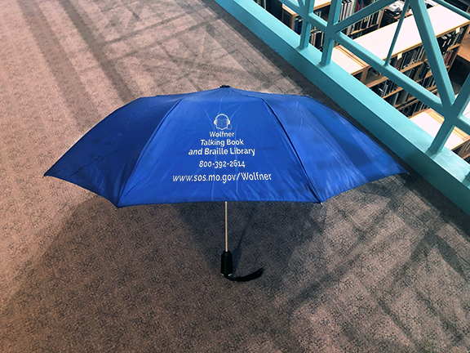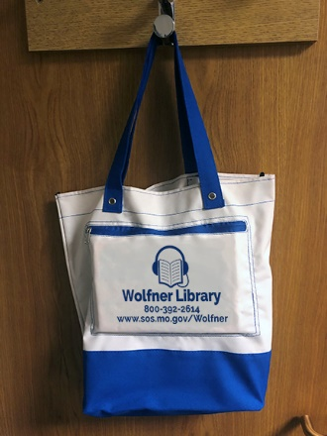

Questions:

- Peter – Does Alzheimer count as a new group of potential patrons even if they can see?
- Leslie - Counted as a print disability.

  - NLS distinction if you can understand the book then you qualify for services. If you have cognitive disability where you can’t understand the book then those do not qualify for services.

  - NLS just finalized the change in certifying authority (Reading Specialist, School Superintendent, and School Phycologist).
  - NLS print disability now includes dyslexia and reading disability not formally recognized.
- Paul – Is Traumatic Brain Injury (TBI) consider as and disability
under the current changes.
- Leslie -TBI is part of print disability qualification and Veterans
get first preference.
- Peter – Any updates since of what will happen in the next 6-months
- Randy - Since COVID, everything we have been operating virtually.
    - We have learned that individuals can be educated at home if they focus on what’s on the screen.
    - If we can acquire a few more laptops this will aid in the continuous of service mobile until things get back to normal.
- Robin – Randy brings so much to the team with his enthusiasm and
wealth of knowledge.

Advisory Council Recommendations
None

Other business

- Peter - asked for the contact list of the council
- Leslie – please provide a brief update, one to two minutes, which the Wolfner staff could share with patrons from those representing a group.
- Paul (Veterans)– The Blind Veterans Association convention will be held tentatively in St. Louis, MO around August and the VA has been well diverse with the COVID vaccinations in KC is doing well but can’t speak for nationwide. Highly dependent on people to use a smartphone. Lots of people are out of the communication change because of the resistance of new technology in the older community.
- Melissa (NFB) – Trying to keep in contact with everyone. The annual convention will be the last weekend in March virtual via zoom. Virtual Braille summer program. New programs to come forth for programs for seniors and youths
- Kerry (MCB) – In process of hiring a new executive director. President Naomi Soule. Library users of MO division (Kerry is secretary) sent $250 to the adult winter reading program for prizes.
- Mandy (RSB-Stl) – Started visiting clients and processing intake and mostly using virtual and postal service to reach patrons. Pushing Wolfner applications over the phone.
- Melissa (RSB-Mid MO Counties) – All of our counties are open still encouraging remote work as much as possible.
- Steve (MSB) - Processed over 150 new digital, braille, and large print books. Reach out to patrons to access their needs. Working closely with special education teachers to assist students with multiple differences. APH developed two new embossers that can be bought with recorded dollars and can do tack tile graphics and multimedia items.
- Paul – Do we know if the rural area is involved with virtual service access? If not can we send them a cartridge to teach them how to use virtual computer services or smartphones in the public libraries?
- Leslie/Robin – Branch libraries have already started classes to teach individuals how to use smartphones, access zoom and learn how to use the internet in person or on the phone. They are also teaching how to use several social media outlets. Some branches have setup hotspots for individuals to use in the parking lots.

Vice Chair Nominees – Brief Bio

- Rita – Retired, passionate
- Kerry – Compassionate, dependable, willing to serve
- Mandy – Masters of Arts/Library Science Technology (Mizzou), work with blind patrons all the time, strongly advocates for Wolfner and services, been a patrons since 1993 (10yrs old)

- Quorum reached for voting (12 people) Typically one over 50%
- Secret voting ballets will be emailed from each member to Peter
- Respond within a week Peter will send results back to Leslie

Meeting Date 2021:

May 21
August 20
Nov 19

Peter as chair
Vice chair nominees Kerry and Mandy

Adjournment:
- Moved - Paul
- Seconded - Rita
- All approved - Yes
- Adjourned at - 11:45 am

