Wolfner News Summer 2026

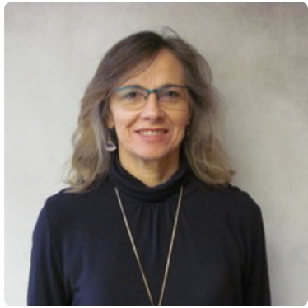
Greetings from the State Librarian
For our summer reading challenges this year, Wolfner Talking Book and Braille Library is going on an adventure to the land of dinosaurs with our theme Unearth a Story™ developed by the Collaborative Summer Library Program (CSLP). We’re getting in the spirit at Wolfner. Reader advisors search our collection for reading suggestions with the persistence of a paleontologist pushing sand aside in hopes of the next great dino discovery. We carefully pack cartridges like fossils heading to the museum. Pterodactyl screeches might be echoing faintly in the recording studio.
While the theme focuses on dinosaurs, it also invites us to enjoy exploration. Perhaps you could plant a new vegetable in your garden, conduct genealogy research to unearth your own story, learn a new craft, or stroll down a new path. Summer is a great time to try out new experiences that may lead to great stories to share with loved ones.

Whether you uncover ten new titles with our adult reading challenge or explore a narrated soundscape with NLS, we hope you will join in the fun and Unearth a Story™ this summer with us. Wolfner will keep you supplied with plenty of reading materials to enjoy the season and make progress on your summer reading goals.
Janet



2026 Wolfner Summer Reading Challenge
Join Wolfner Talking Book and Braille Library, June 1 – July 31, as we dig into good books! The 2026 theme Unearth a Story™ encourages us all to engage with the joy of discovery. Featured book lists, filled with dragons, dinosaurs, and curious mysteries, await you!

Youth
Wolfner patrons ages 18 and under are invited to participate in our youth summer reading challenge. Youth patrons who complete their challenge will be entered into our grand prize gift card raffles of $50, $25, $10 (per reading level). All participants will receive a summer reading swag bag.
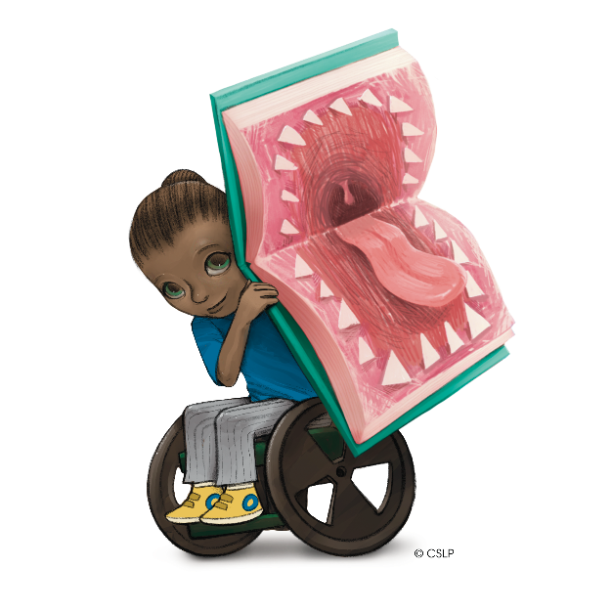
Kid’s Dino Dig Challenge (developmental ages 0-6) Log 10 minutes for a reading swag bag; log 60 minutes for prize raffle entry.
Youth Prehistoric Book Nook (developmental ages 7-12) Log 20 minutes for a reading swag bag; log 120 minutes for prize raffle entry.
Young Adult, It’s a Wild World (developmental ages 13-18) Log 20 minutes for a reading swag bag; log 120 minutes for prize raffle entry.

WonderBox Giveaways
The print-braille book, That's Not My Dinosaur, will be part of WonderBox giveaways available to Wolfner youth patrons. Information on ordering a WonderBox through National Library Service for the Blind and Print Disabled will be shared with registered youth patrons.
Older students are encouraged to join the Narrated Soundscapes series, detailed in our adult summer reading article.

Adults
Wolfner adult patrons are invited to read and log 10 books during the months of June and July. They can self-log online through the Beanstack platform, email, or call Wolfner Library and log with a reader advisor. Participation prizes will be provided by Friends of Wolfner Library. Patrons who complete the challenge will be entered into a raffle for grand prizes.
Participating patrons can call Wolfner Library to have a tactile dinosaur coloring sheet and a pack of wildflower seeds sent to them!
Registration for youth and adults is still open; contact Wolfner Library:
By phone 573-751-8720
By email wolfner@sos.mo.gov
Or online https://wolfpac.beanstack.com/reader365

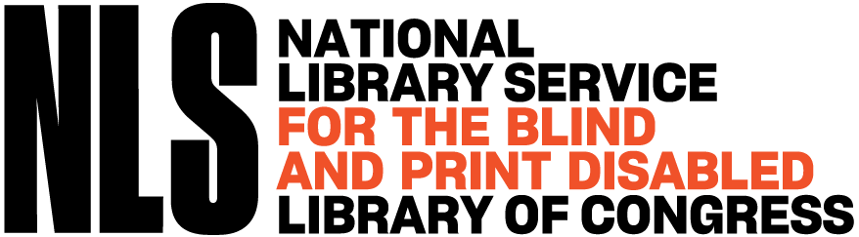

NLS Summer Reading Program
Additional summer programming will be provided by the Braille Institute Library and National Library Service for the Blind and Print Disabled, June 15 – August 11.
To participate, you must register with an email address through the Braille Institute-Zoom Webinar Link or call 888-245-2471 to register by phone.

Summer Reading Kick Off, hosted by NLS
Monday, June 15, 3:00 p.m. central
Hear from special guests and get a preview of all the fun summer programming available to patrons.
Narrated Soundscapes
National Library Service for the Blind and Print Disabled and the Braille Library Institute, in collaboration with National Parks Service Rangers and the Library of Congress sound designers, invite patrons to “walk through” narrated soundscapes this summer. Beginning Monday, June 22, a new soundscape will be shared every other week and can be accessed throughout the summer so patrons can explore at their own pace. Soundscapes will be available at brailleinstitute.org/summer-reading-program/.
Badlands National Park (releases June 22)
Hawaii Volcanoes National Park (releases July 6)
Everglades National Park (releases July 20)
Cape Cod National Park (releases August 3)

Panels and Author-led Events
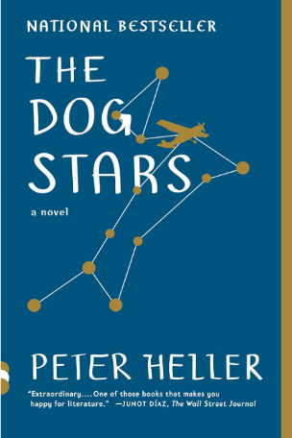
Peter Heller and Maeve Conran
Tuesday, June 16, 3:00 p.m. central
Join best-selling author Peter Heller, along with public radio journalist Maeve Conran, as they discuss his novels, The Dog Stars (DB075493) and The Orchard (DB134029).

National Parks as Living Archives: Stories from New Mexico
Tuesday, June 30, 3:00 p.m. central
National Park Service staff and partners explore the science, history, and culture embedded in Aztec Ruins National Monument, Manhattan Project National Historical Park, and Valles Caldera National Preserve.

Leona Godin and Georgina Kleege
Tuesday, July 14, 3:00 p.m. central
Blind authors Leona Godin, There Plant Eyes (BR023825, DB104014), and Georgina Kleege, More Than Meets the Eye (BR022550, DB093533), explore nonfiction as excavation in conversation.


Excavating a Life: Megan Marshall
Tuesday, July 28, 3:00 p.m. central
Pulitzer Prize-winning biographer Megan Marshall will be in conversation with author Heather Clark about her memoir After Lives (DBC11807).

Digging Up the Past: A Historical Fiction Panel
Tuesday, August 11, 3:00 p.m. central
Join authors Sadeqa Johnson, Elizabeth Wein, and Jess Shaara. Author-led exploration of the research, craft, and creative rewards of historical fiction.

Audio Magazine Selections
Wolfner Library offers patrons more than 70 audio magazines on cartridge and more than 40 Braille magazines. We offer a wide variety of subjects, including health and nutrition, news and entertainment, science, history, and children’s magazines. Some of our most popular titles include: Reader’s Digest, The Atlantic Monthly, People, Ellery Queen Mystery Magazine, Consumer Reports, and AARP Magazine.

Audio magazines and the audio Talking Book Topics cartridges must be returned when finished to ensure the timely delivery of future issues. Wolfner Library has a limited number of audio cartridges. To receive your next magazine issue or Talking Book Topics catalog, please return your audio cartridge.

If you would like to subscribe to audio magazines or have questions about magazine ship dates, please contact a reader advisor at 573-751-8720 or wolfner@sos.mo.gov.

New CVI Youth Resources
New accessible books for children with cortical visual impairments have been added to the Wolfner youth collection. Little Dandelion Press, a publisher that specializes in high-contrast picture books, has developed a line of inclusive children’s books for early learners with CVI. Wolfner Library is pleased to share these new additions with our youngest patrons. Our collection now includes red-bubble letter alphabet books, the color series, and an animal habitat series. We look forward to adding more CVI-informed materials to our collection and invite families to borrow these high-contrast visual books.
These materials were funded by the Institute of Museum and Library Services under the provisions of the Library Services and Technology Act as administered by the Missouri State Library, a division of the Office of the Secretary of State.


Return Extra Equipment
If you are a Wolfner patron who has received the new generation digital player, the DA2, or a patron with multiple playback machines, please return your extra audio equipment to Wolfner Library. We have a limited number of machines for Missourians to check out, and others can use your extra player. Remember, all equipment loaned to you from Wolfner is property of the federal government. National Library Service for the Blind and Print Disabled allows each patron only one playback machine.
Please call a Reader Advisor with any questions or to order a free box to return your extra machine. Do not pay postage; all Wolfner library equipment can be mailed Free Matter.



2026 Upcoming Book Club Titles
If you are a Wolfner patron, participate in our book club by dialing in on the first and third Thursday of each month at 2:00 p.m., or by using Zoom from a smart device.
Here’s a list of books that will be featured for June through August, followed by instructions on how to join in:

June 18—The Secret Book Society: A Novel by Madeline Martin DB132261
You are cordially invited to the Secret Book Society ... London, 1895: Trapped by oppressive marriages and societal expectations, three women receive a mysterious invitation to an afternoon tea at the home of the reclusive Lady Duxbury. Beneath the genteel facade of the gathering lies a secret book club -- a sanctuary where they can discover freedom, sisterhood, and the courage to rewrite their stories…--From publisher. Unrated. 7 hours, 51 minutes

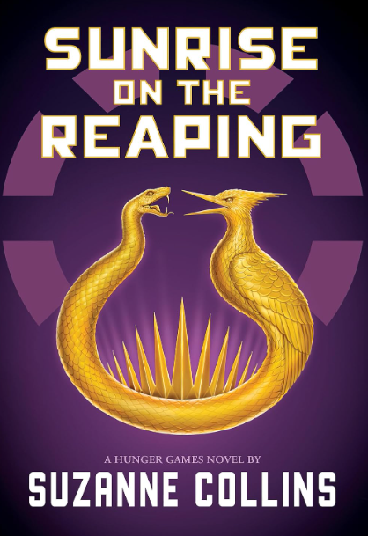
July 2—Sunrise on the Reaping by Suzanne Collins DB127954, BR026205
As the day dawns on the fiftieth annual Hunger Games, fear grips the districts of Panem. This year, in honor of the Quarter Quell, twice as many tributes will be taken from their homes. Back in District 12, Haymitch Abernathy is trying not to think too hard about his chances. When Haymitch's name is called, he can feel all his dreams break…As the Games begin, Haymitch understands he's been set up to fail. But there's something in him that wants to fight...and have that fight reverberate far beyond the deadly arena.-- From publisher. Violence. 12 hours, 52 minutes

July 16—The Café by the Sea by Jenny Colgan DB088776
Years ago, Flora fled the quiet Scottish island where she grew up - and she hasn't looked back…But when fate brings Flora back to the island, she's suddenly swept once more into life with her brothers - all strapping, loud, and seemingly incapable of basic housework - and her father. Yet even amid the chaos of their reunion, Flora discovers a passion for cooking - and finds herself restoring a dusty little pink-fronted shop on the harbour: a cafe by the sea. Strong language. 10 hours, 31 minutes
August 6—Woman in the Mists by Mowat Farley DB027071
At the time of her mysterious murder in December 1985, Dian Fossey was a noted ape researcher. Living twenty years in Africa, Fossey conducted her research in Rwanda facing such constant hardships as the wild environment, poachers, and arrogant officials who many believe arranged for her death. The story is presented in detail, relying on Fossey's journals, letters, and notes. Some strong language. 16 hours, 41 minutes


August 20—Flowers for Algernon by Daniel Keyes DB033245, BR018365
Charlie Gordon, a thirty-two-year-old with an IQ of 68, keeps progress reports for the doctors who artificially increase his intelligence through surgery. Charlie quickly becomes a genius, but the sudden death of Algernon, the lab mouse who preceded him in the experiment, bodes ill for Charlie's future. Nebula Award. 1966. 8 hours, 20 minutes
Participants may call Wolfner via phone to be linked into the meeting, or:

Join with Zoom on any smart device: https://zoom.us/j/96471504467
Join by phone by dialing: (312) 626-6799
Enter the meeting ID when prompted: 964 7150 4467
For one tap mobile:
+13126266799,,96471504467# US

Kind Notes from Wolfner Friends
“Thank you so much to Friends and to the staff and volunteers for all that you do on a regular basis to provide this wonderful service to all of us...Being able to continue my love of reading is so valuable to me. I am so grateful.” Judith, Saint Louis

“[Our daughter] absolutely LOVED her care packet for [the youth] summer reading! The wooden snake was a huge hit! Thank you for making her day so special!” Tiffany, Fair Grove

“It has been 22 years since [my grandson] was stricken with Adrenoleukodystrophy (ALD)…It’s been a blessing to have him focus on his audiobooks, and he even was able to graduate High School as a special ed student. I really think learning to concentrate on the spoken word, from his stories, has helped him tremendously. Thanks to Wolfner Library.” LouAnn, Kansas City

New from the Wolfner Recording Studios
All books produced by the Wolfner Recording Studios are the result of many hours of service by volunteers who go through a rigorous audition process to record, monitor and review each title. These Missouri-centric titles are uploaded to BARD for the enjoyment of Wolfner patrons and readers across the country.
(Additional studio funding is provided by Friends of the Wolfner Library.)

Youth
Follow Your Dreams: 100 Inspiring and Extraordinary Jobs by Katherine Mengardon. DBC33044 Narrated by Loretta Broker.
In this book, you’ll discover jaw-dropping jobs that put the WOW into the world of work. The careers are arranged by interest, to make the content engaging and easy to navigate, with exciting ‘jobs of the future’ in cutting-edge areas like AI and the environment. For grades 3-6. 4 hours, 47 minutes

Alohalani Welcomes Change by Tricia Orscheln. DBC33058

Narrated by Tricia Orscheln.
"Lani," who is making a big move from her hometown in Missouri to the beautiful island of Kauai. This change causes Lani to experience some anxiety along the way, and she must learn how best to manage that feeling. Along with being introduced to some of the language and culture of Kauai, children reading this book will learn a mindfulness technique that they, and their parents, can implement to manage anxiety in everyday life. For grades K-3. 19 minutes

The Man Who Didn't Like Animals by Deborah Underwood. DBC33073 Narrated by Melanie Melton.
There once was a man who loved his tidy home and who didn’t like animals. Then, one day, a cat appeared. The man and the cat both liked napping and watching the rain and eating dinner precisely at six. Well, maybe this one animal could stay. For preschool-grade 2. 8 minutes

Rory the Remarkable Dragon by Kathryn Rammell. DBC33075
Narrated by Anne Rottmann.
Rory enters the Dragon Academy, School for Gifted Dragons, and quickly becomes the most popular dragon there, but she seems very different from the other dragons. For preschool-grade 2. 8 minutes

Old MacDonald Had a Farm E-I-UFO by Zach von Zonk. DBC33080
Narrated by Caroline Ward.
When a spaceship visits Old MacDonald's farm chaos ensues as the farm animals make a mess of Old MacMartian's vessel. For preschool-grade 2. 7 minutes

Adult
Faces Like Devils by Matthew J. Hernando. DBC09732 Narrated by Dennis Donley.
Despite being one of America's largest and most famous vigilante groups during the nineteenth century, the Bald Knobbers have not previously been examined in depth. Hernando's exhaustive research, which includes a plethora of state and federal court records, newspaper articles, and firsthand accounts, remedies that lack. This account of the Bald Knobbers is vital to anyone not wanting to miss out on a major part of Missouri's history. Some violence. 12 hours, 16 minutes


When the Missouri Ran Red by Jim R. Woolard. DBC32967 Narrated by John Wegman.
Set in the final months of the American Civil War, this powerhouse of a novel from award-winning author and master historian Jim R. Woolard follows a young man's harrowing journey from Confederate captive to Union prisoner to unchained force of vengeance. Some strong language. Some violence. 12 hours, 49 minutes

Weddings at Promise Lodge by Charlotte Hubbard. DBC33006 Narrated by Theresa Sullivan.
It's love at first sight for Christine Bender when widower bishop Monroe Burkholder comes to Promise Lodge, but the arrival of a young woman who claims Monroe has "ruined" her leads to complications. 9 hours, 45 minutes

100 Things To Do In Kansas City Before You Die by Traci Angel. DBC33038 Narrated by Shirley Baker.
The secret is out--Kansas City is not only an affordable, friendly place to live and work, it also has a lot to offer when it comes to culture, history, and outdoor adventure. 100 Things to in Kansas City Before You Die celebrates all that makes the area the cool, quirky, iconic Midwestern place that it is while highlighting the hip, international, and cultural oasis it represents to the outlying rural areas. 2 hours, 49 minutes

Forgotten Tales of Kansas City by Paul Kirkman. DBC33041
Narrated by Tim Emmel.
Meet the folks who slip out of history books like they're playing the Kansas City shuffle. In this fascinating collection of stories, Paul Kirkman has dug up all sorts of head-scratchers: how did Jesse James rob a bank with John F. Kennedy, and how could a Beatles concert in the 1960s fail to make money? 3 hours, 15 minutes

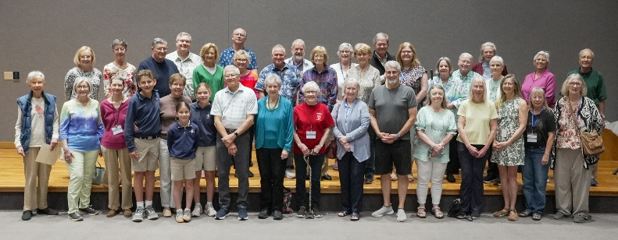

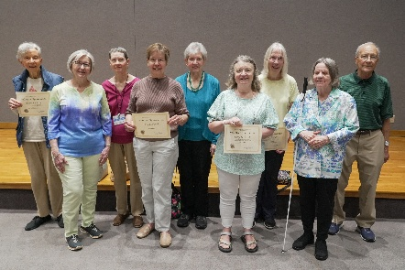
Wolfner Studio Recognizes Volunteers
The annual luncheon to celebrate Wolfner’s wonderful volunteers was held on Friday, April 24th. Accomplishments over the previous year were reflected upon, and several volunteers were recognized for their years of service. This event was made possible due to the generosity of the Friends of Wolfner Library and it allowed us to show our volunteers some well-deserved appreciation.
Our volunteers play a vital role in the success of Wolfner Talking Book and Braille Library. If you would like to help us acknowledge our volunteers, feel free to send a thank-you note or let us know about a Wolfner volunteer-produced book or Wolfner narrator you have enjoyed.

Wolfner Facebook
Stay connected with all the latest news, events, and resources provided by Wolfner Talking Book and Braille Library by following us on Facebook at https://facebook.com/wolfnerlibrary.

NLS Programs

NLS Celebrates Semiquincentennial

NLS is working to provide accessible materials relating to America’s 250th birthday celebration, our semiquincentennial.

In addition to accessible versions of Revolutionary War-era maps, an Accessible 250 web page will have an audio version of the Constitution Annotated, which combines documents from the nation’s founding with expert analysis and compelling narration. The NLS Media Lab created the Constitution Annotated audio in collaboration with the Law Library of Congress. More information forthcoming.

Monthly The Many Faces of BARD
The Patron Engagement Section of NLS offers a monthly program called The Many Faces of BARD on the second Thursday of each month at 6:00 p.m. central time. Each monthly event covers one aspect of BARD (Braille and Audio Reading Download offered by the National Library Service for the Blind and Print Disabled, Library of Congress). This event is open to all.
BARD, an online audiobook and braille service, debuted in 2009. In the 2025 federal fiscal year, patrons downloaded more than 4.3 million audio titles from BARD!
For more information, please visit www.loc.gov/nls/news-and-updates/many-faces-of-BARD/ or call a Wolfner reader advisor at 800-392-2614 or 573-751-8720.

Upcoming Holidays As a reminder to patrons, Wolfner Library will be closed on the following holidays:
Friday, June 19 Juneteenth
Friday, July 3 Independence Day (observed)
Monday, September 7 Labor Day

Wolfner Library Donations
If you are interested in donating to Wolfner Library, there are two options:
1. Help offset operating expenses through the Wolfner Trust Fund:

Wolfner Talking Book and Braille Library,
PO Box 387
Jefferson City, MO 65102

2. Help provide patron programming through Friends of Wolfner Library:
Friends of Wolfner Library PO Box 24834 Kansas City, MO 64131
For information on how to become a Friend of Wolfner Library, you can email wellsjerry9@gmail.com or phone 816-678-1257.
Wolfner Library and our patrons appreciate your support!

Wolfner Staff
Director Janet Caruthers, State Librarian
Public Services Team
Lori Brown, Public Services Director Jami Livingston, Adult Services Librarian Vanessa Lengyel, Youth Services Specialist Meghan McCormack, Reader Advisor Kenna Tervo, Reader Advisor Jon Wilcox, Reader Advisor
Circulation Team Verhonda Winters, Circulation Director Stacy Jo Butler, Senior Library Tech Germone Williams, Library Tech Emma Deuschle, Library Tech Justin Stauffer, Library Tech
Recording Studio Team Brandon Lammers, Volunteer and Recording Studio Manager Chris Cowan, Senior Library Tech Tim Emmel, Library Tech Germone Williams, Library Tech

